

**Introduction:**

The provided code focuses on building a linear regression model to predict mobile phone prices. Accurate price prediction is crucial in the highly competitive smartphone market, assisting consumers in making informed decisions and aiding manufacturers in strategic pricing. This analysis aims to leverage machine learning techniques to understand the factors influencing phone prices.

**About the Dataset:**

The dataset used in this analysis is sourced from the file located at '/content/Mobile phone price.csv.' It presumably contains information about various mobile phones, including features such as brand, model, storage capacity, camera specifications, RAM, screen size, battery capacity, and, most importantly, the price in dollars.

**Data Exploration:**

The initial steps involve exploring the dataset to understand its structure and characteristics. This includes examining unique values and counts for the 'Brand' and 'Model' columns, which provide insights into the diversity of phone manufacturers and models present in the dataset. Understanding the dataset's uniqueness is crucial for subsequent data cleaning and analysis.

**Data Cleaning:**

The code executes a series of data cleaning steps to ensure the dataset is suitable for analysis. This includes handling missing values, removing duplicates, and converting certain columns to numeric formats. The cleaning process ensures the integrity and accuracy of the data, laying a solid foundation for subsequent analysis.

**Visualization:**

Visualizations, such as heatmaps, box plots, scatter plots, and histograms, are employed to gain insights into the relationships between various features and their potential impact on phone prices. Exploring correlations helps identify patterns and trends, guiding the feature selection process for the predictive model.

Heatmap of the correlation matrix: Boxplot to visualize the distribution of

"Battery_Capacity_(mAh)" across different brands:

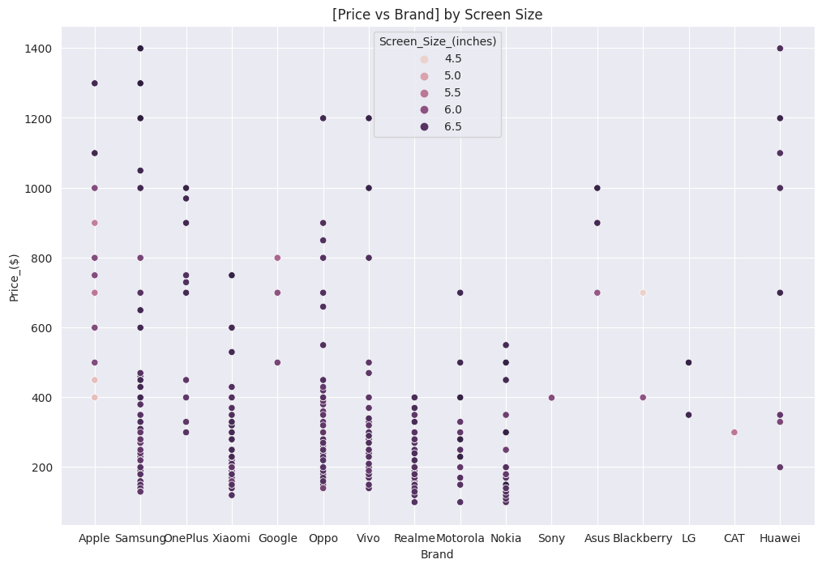

Scatter plot to visualize the relationship between Histogram of the "Price_($)"

the "Price_($)" and "Screen_Size_(inches)" variables:

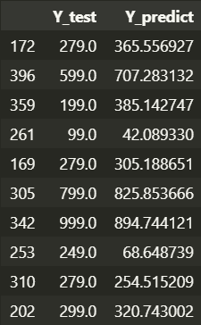 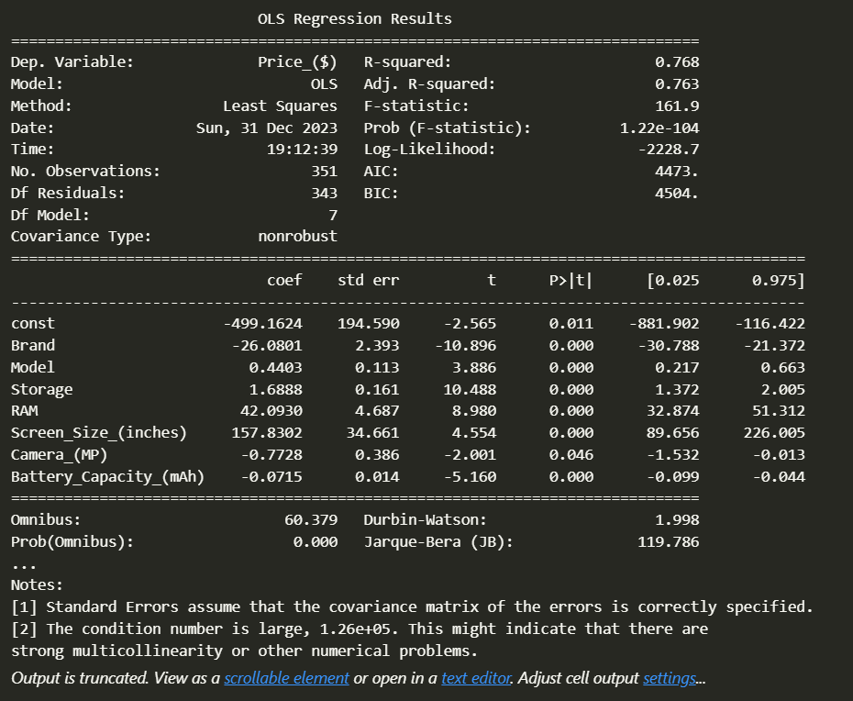

Model evaluation Various statistics and information about the regression model

**Team members:**

* **Name: Omar EmadEL-Din ID: 221101037**
* **Name: Ahmad Talat ID: 221101084**